**Description:**

Former Di Manes who lost their power for an unknown reason and failed to become a God.

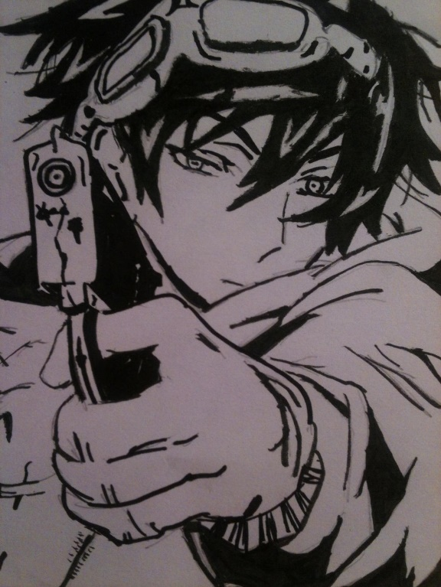

A single man cut through the thick stillness, his voice, gentle, but imbued with conviction. He had unruly brown hair. His head was adorned by a pair of goggles. Sharp sky-blue eyes overlooked the other attendants. He donned a brown cloak over his clothes but everyone present knew that beneath it was a coal-black set of complex gears and a tightly fit suit that was designed to carry those gears without impeding the wearer’s range of motion. Of the many people who came from various origins, not a single one could understand the extent of potential stored in his complex apparatuses.

**Soul:**

**Abilities:**

**Weapons:**

**Physical Details:**

Age A

Gender A

Race/Heritage A

Height A

Weight A

Body Posture and Bearing A

Distinguishing Marks A

Physical Challenges A

Overall Condition and Presentation A

Clothing Style Preferences A

Common Adornments A

**Daily Life:**

*Family and General Life*

A

*Talents and Skills*

A

*Occupation*

A

*Hobbies*

A

**Backstory:**

<Summary>

*Wound*

A

*Fear*

A

Because of these:

*Lie*

A

*Secrets*

A

**Personality:**

*Positive Traits*

Influencers/Role Models

A

Past Achievements and Sources of Pride

A

Ethics and Values

A

Environmental Contributions

A

Traits

A

*Negative Traits*

Bad Influencers/Role Models

A

Unjust/Unfair Experiences

A

Painful Memories

A

Negative Life Lessons

A

Traits

A

**Behavior:**

*Core Behavior*

A

*Emotional Range*

Idle: A

Stressed: A

Exhausted: A

Inebriated: A

Overstimulated: A

Anxious: A

Distracted: A

Bored: A

Attraction: A

Aroused: A

X

X

X

X

X

*Negative Coping Mechanisms*

A

*Positive Coping Mechanisms*

A

*Uncomfortable Emotions*

A

*Quirks*

A

**Motivations:**

*Outer Motivation*

A

*Inner Motivation*

A

*Emotional Shielding*

A

*Fatal Flaw*

A